The Process

A process is basically a program in execution. The execution of a process must progress in a sequential fashion. A process is an instance of a program in execution.
Batch systems work in terms of "jobs". Many modern process concepts are still expressed in terms of jobs, (e.g. job scheduling), and the two terms are often used interchangeably.

A process is defined as an entity which represents the basic unit of work to be implemented in the system.
To put it in simple terms, we write our computer programs in a text file and when we execute this program, it becomes a process which performs all the tasks mentioned in the program.
When a program is loaded into the memory and it becomes a process, it can be divided into four sections ─ stack, heap, text and data. The following image shows a simplified layout of a process inside main memory.
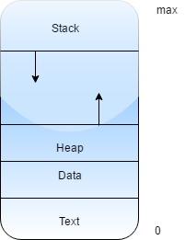

Figure - A process inside main memory.
Component & Description:
Stack: The process Stack contains the temporary data such as method/function parameters, return address and local variables.
Heap: This is dynamically allocated memory to a process during its run time.
Text: This includes the current activity represented by the value of Program Counter and the contents of the processor's registers.
Data: This section contains the global and static variables.

There is two types of processes:
(i) System process: These process cannot be preempted and executed in privileged mode.
(ii) User process: These process can be preempted and executed in user mode.

Every process has three parts first is executable program or code section, second is data section and third is context section. Context section of a process contains stack and process control information which managed by operating system. Code and data section of a program are called as user address space.

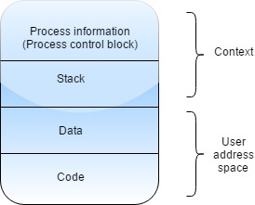
Figure – Three parts of a Process

Types of Process: There is three type of process:
- CPU - Bound: Process needs more service by CPU than I/O service.
- I/O - Bound: Process needs more I/O service than CPU service.
- Interactive: Process spends more time in waiting queue than CPU burst time.

Process State
When a process executes, it passes through different states.
These stages may differ in different operating systems, and the names of these states are also not standardized.
In general, a process can have one of the following five states at a time.

State & Description
Start State: This is the initial state when a process is first started/created.
Ready State: The process is waiting to be assigned to a processor. Ready processes are waiting to have the processor allocated to them by the operating system so that they can run. Process may come into this state after Start state or while running it by but interrupted by the scheduler to assign CPU to some other process.
Running State: Once the process has been assigned to a processor by the OS scheduler, the process state is set to running and the processor executes its instructions.
Waiting State: Process moves into the waiting state if it needs to wait for a resource, such as waiting for user input, or waiting for a file to become available.
Terminated or Exit State: Once the process finishes its execution, or it is terminated by the operating system, it is moved to the terminated state where it waits to be removed from main memory.

Types of Process: There is three type of process:
- CPU - Bound: Process needs more service by CPU than I/O service.
- I/O - Bound: Process needs more I/O service than CPU service.
- Interactive: Process spends more time in waiting queue than CPU burst time.

Two more states are suspended ready and suspended blocked. A process moves from ready state to suspended ready due to more priority for other processes. A process moves from waiting state to suspend blocked state due to process might be consuming more memory.

Note: that ready state, running state and waiting state are always resides in main memory and new state, suspended ready and suspended blocked state resides in secondary memory.

There are four types of process model:
- Two state process model
- Five state process model
- Six state process model
- Seven state process model

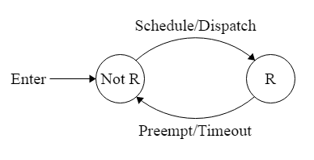
Figure - Two state process model.
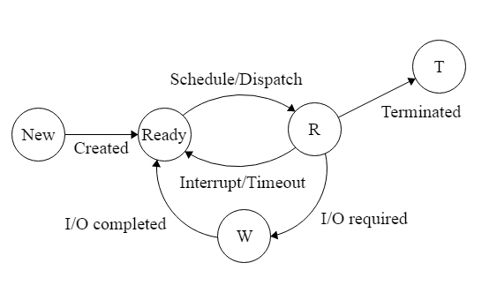
Figure - Five state process model.

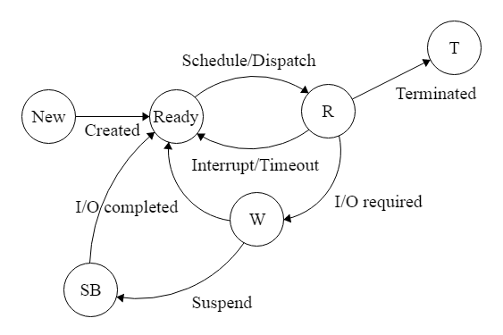

Figure - Six state process model.
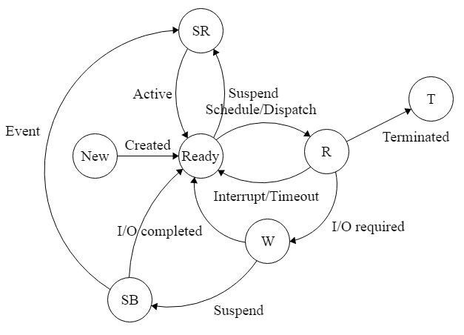

Figure - Seven state process model.

Where R = Running, W = Waiting, T = Terminated, SB = Suspended block, and SR = Suspended ready state. Preemption, dispatch, schedule, suspend, created, active, terminated etc. are actions that performed by operating system.

Text Books:

1.Abraham Silberschatz, Peter B. Galvin, Greg Gagne, ―Operating System Principles‖, Wiley Student Edition, 8th Edition, 2010.
2.William Stallings, ―Operating System- Internals and Design Principles‖, Pearson Education, 6th Edition, 2002.

Reference Books:

1. Andrew S Tanenbaum, ―Modern Operating Systems‖, PHI, 3rd Edition, 2007.
2. D. M. Dhamdhere, ―Operating Systems a Concept based Approach‖, Tata McGraw-Hill, 2nd Edition, 2006.

